Model Deployment and Responsible Reporting
Final Task 2 Report

1. Objective
The goal of this task was to take the model chosen in Final Task 1 and prepare it for practical use: define how it will actually be used, validate the inputs it receives, check whether it treats different parts of the business fairly, plan how to monitor it after launch, and write a stakeholder report that is honest about what it cannot do.
A model sitting in a notebook helps nobody. But a model put in front of real users without input checks, fairness checks or a monitoring plan is worse than no model, because people will trust it without knowing when it is wrong.

2. The Inference Workflow
This is how a single prediction happens from start to finish:
User fills in the form in app.py
|
validate_input() -> if anything is wrong, show an error and STOP
|
build_features() -> calculate the 4 engineered features
|
model.predict_proba() -> probability of profit
|
Show result + the reason behind it

The important design decision is that the four engineered features (Revenue Per Unit, Shipping Cost Ratio, Discount Value and Order Month) are calculated inside the app rather than asked for on the form. A user should enter sales and shipping cost, not be asked to work out a ratio themselves.
This creates a rule though: the app's formulas must match the notebook's exactly. If they differed, every prediction would be quietly wrong with nothing to indicate it.

3. Saving the Model
Three files are saved. The model itself, an information file holding everything the app needs to know, and a baseline statistics file used for monitoring.
File | Contents
profit_model.joblib | The trained Gradient Boosting pipeline including its preprocessing
model_info.joblib | Valid category options for every dropdown, model scores, training date
baseline_stats.json | A snapshot of the training data, used for drift checks

Saving the category lists matters more than it first appears. Without them the app would have to hard-code every dropdown option, and those would silently fall out of sync the moment the underlying data changed. After saving, the model was loaded straight back and confirmed to produce identical predictions.

4. Input Validation and QA Evidence
The model will accept almost anything it is given and return a confident number. A negative quantity, a discount of 5.0, a shipping cost higher than the sale value: none of these raise an error, they simply produce nonsense. So the app checks every input before the model ever sees it.
Eight test cases were run: one valid order and seven with a deliberate problem. Each states what should happen and the result is compared against that.
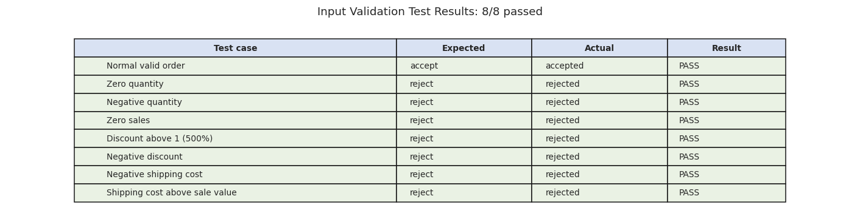
Figure 1: Input validation test results, 8 of 8 passed
All eight behave as expected. The valid order is accepted and every deliberately broken input is caught with a message explaining what is wrong.
The last case is the interesting one. A shipping cost higher than the sale value is not impossible in reality, but it is unusual enough that it is far more likely to be a typing mistake, so the app asks the user to check rather than silently predicting on it. Rejecting it outright would block a genuine case; accepting it silently would hide an error.

5. Fairness and Risk
A model can have good overall accuracy while working badly for one particular group. If this model were much worse for one region, that region's orders would be flagged incorrectly more often than everyone else's, and nobody would notice from the headline score. So accuracy was measured separately for each group.
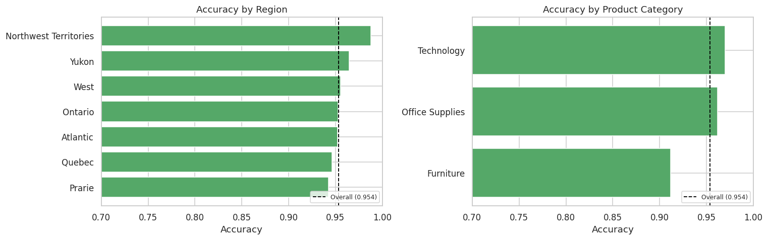
Figure 2: Accuracy by region and by product category, against the overall score
Measure | Value
Overall test accuracy | 95.4%
Best group | Northwest Territories, 98.8%
Worst group | Furniture, 91.2%
Spread between best and worst | 0.076

Across regions and customer segments the model is very even, with every group within about one point of the overall score.
The one gap worth naming is Furniture at 91.2%, about 4 points below overall.
That is not large enough to call the model unfair, but it is not a coincidence either. Furniture is the category holding the most bulky, awkward, high-shipping products, which is exactly the situation the model finds hardest to call. Furniture orders should be treated as slightly less reliable, and this gap should be watched after deployment rather than assumed to stay small.

6. Monitoring After Deployment
A model does not stay accurate on its own. The data it sees in six months will not look exactly like the data it was trained on, and when that happens the model degrades quietly. No error appears, the predictions simply get worse.
The approach taken here is to save a snapshot of what the training data looked like (mean, median, standard deviation and the 5th and 95th percentiles for every numeric column, plus the share of each category) so that future data can be compared against it. The check_drift function flags any column whose mean has moved by more than 0.25 standard deviations.
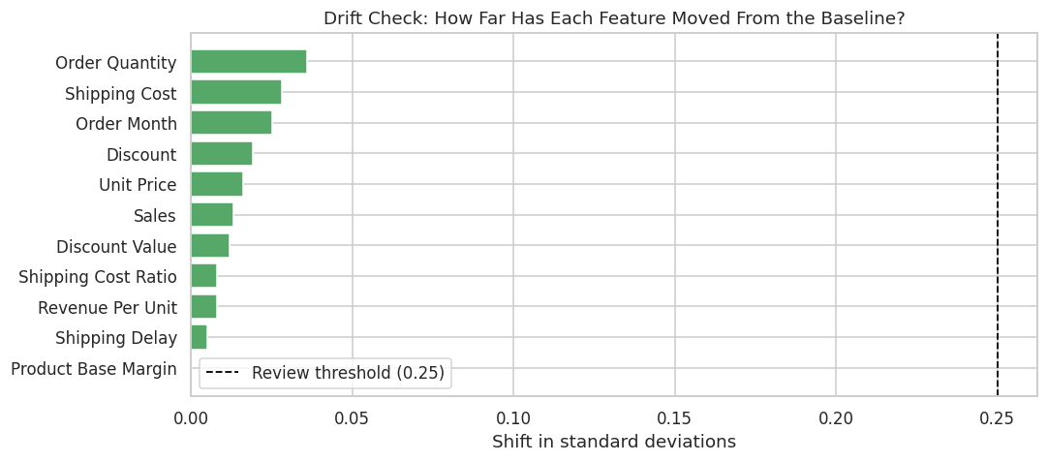
Figure 3: Drift check, no columns flagged for review

The monitoring plan
What to track | How often | Action if it moves
Feature drift | Monthly | Investigate the flagged column. A pricing or shipping change is the usual cause
Real accuracy, once actual profit is known | Quarterly | Retrain if it falls more than 5 points below 95%
Share of orders predicted profitable | Monthly | A sudden swing usually means the input data changed
Fairness gaps across groups | Quarterly | Investigate any group 5+ points below overall
Rejected inputs in the app | Monthly | A spike suggests users are confused by a form field

The second row is the one that matters most. Every other check is a proxy. Once the real profit figures come in, the model's predictions can be compared against what actually happened, and that is the only measurement that truly counts.

7. The Deployed Application
app.py is a Streamlit application that loads the saved model and runs the workflow from section 2. It is started with the command streamlit run app.py.
The app loads the model once and caches it so it does not reload on every click, builds its dropdown options from the saved model information file so they can never fall out of sync with the training data, validates every input before predicting, shows the probability rather than just a yes or no, warns when a result is borderline, explains the main reason behind each prediction in plain language, and states clearly that it is a decision support tool rather than an automatic approval system.
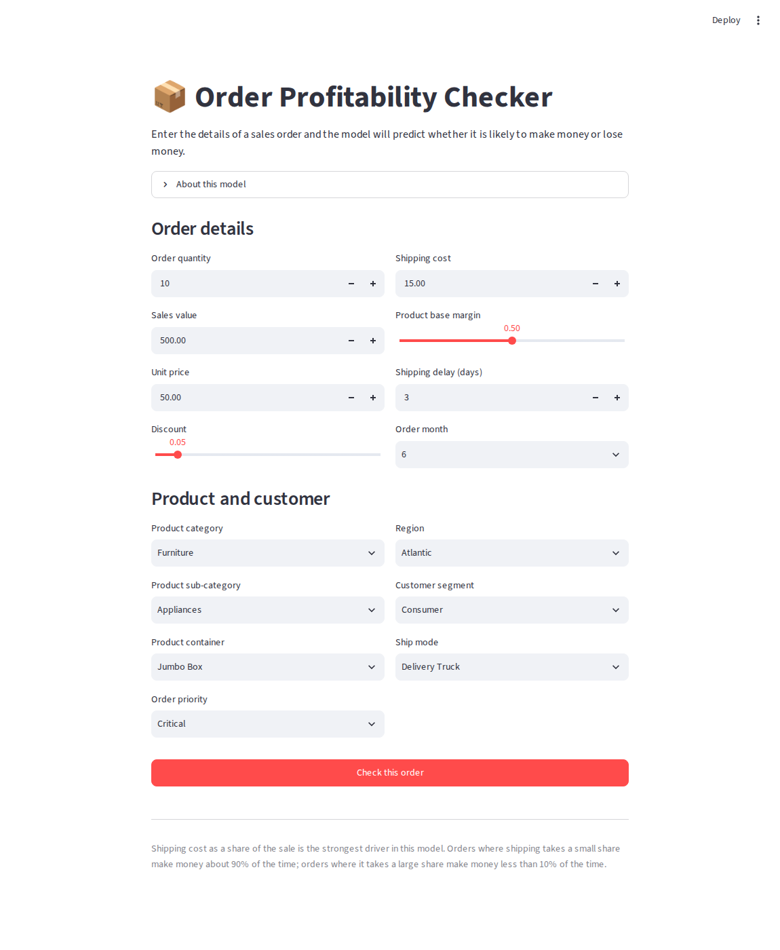
Figure 4: The application input form

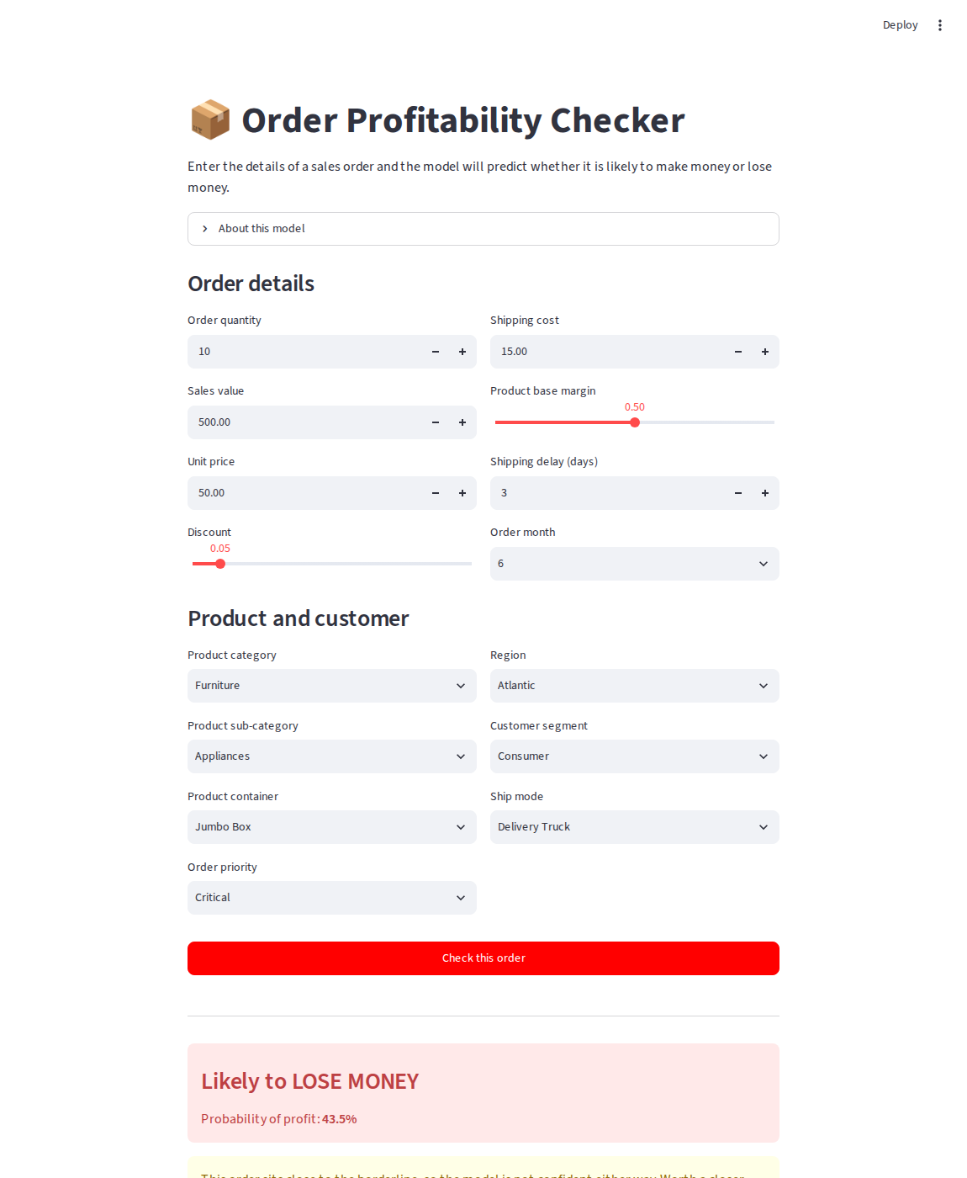
Figure 5: A borderline order at 43.5%, with the low-confidence warning showing
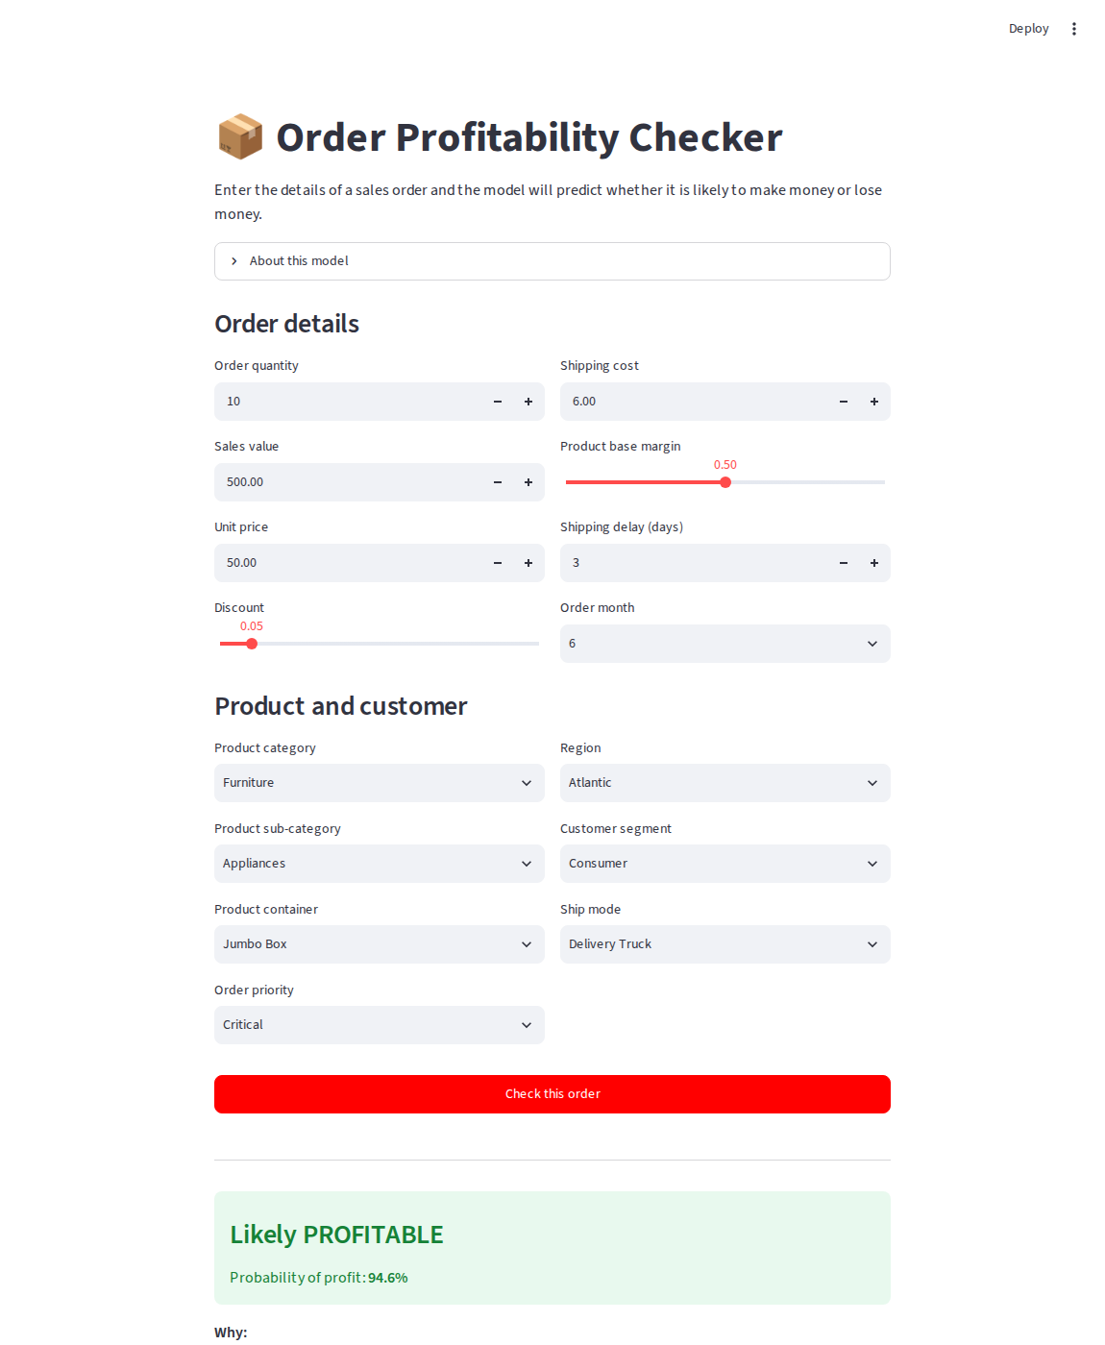
Figure 6: The same order with shipping cost lowered from 15 to 6, now 94.6% profitable

Figures 5 and 6 are worth reading together. The only thing changed between them is the shipping cost, from 15 to 6 on a 500 sale, and the prediction moves from 43.5 percent to 94.6 percent. That is the model's top driver visible in the live application rather than only in a chart.
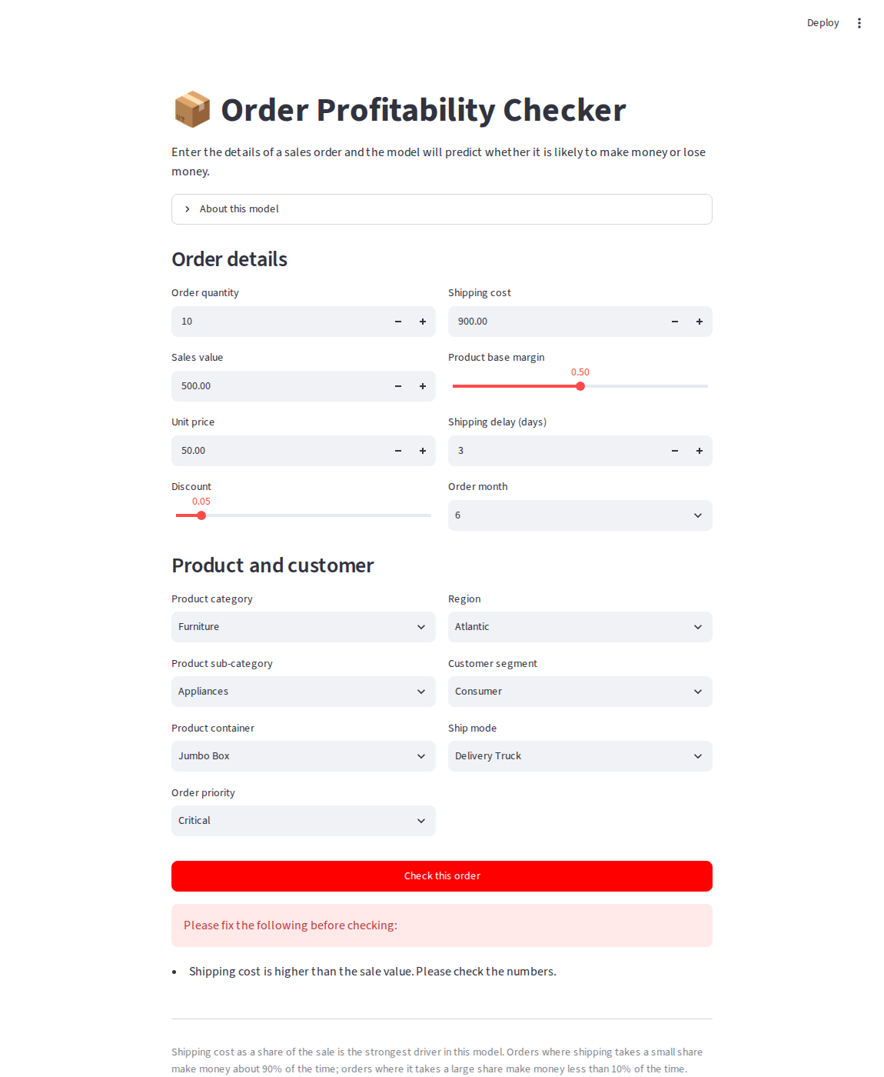
Figure 7: Input validation rejecting a shipping cost higher than the sale value

8. Stakeholder Report
Written for a manager, not a data scientist.

What this is
A tool that checks a sales order before it is fulfilled and says whether it is likely to make money or lose money. Staff enter the order details on a simple web form and get an answer immediately, along with the main reason behind it.

Why it was built
Just over half of all order lines in the historical data lost money. Sales figures looked healthy while profit did not. This tool makes that visible on individual orders, before the money is spent rather than after.

How well it works
It is right about 95 times out of 100 on orders it has never seen. That figure comes from a portion of the data that was deliberately set aside and never used while building the model, so it is a fair estimate rather than a flattering one.

How it should be used
As a warning, not as a gate. Orders the tool flags should go to a person for review. It should not reject orders automatically.
The reason is in its mistakes. Out of 1,680 test orders it approved 28 that actually lost money, and flagged 50 that were actually profitable. If it ran without human review, those 50 profitable orders would have been turned away.

What it cannot do
- It does not know what the goods cost to buy. That column does not exist in the data, so the tool estimates profitability from price, discount and shipping instead. This is the biggest single limitation.
- It looks at one order line at a time. An order that loses money but wins a valuable long-term customer looks like a plain failure to this tool.
- It learned from past trading. If pricing or shipping policy changes, parts of it will go out of date, and it will not announce that it has.
- It shows patterns, not causes. It can say that orders with high shipping ratios tend to lose money. It cannot prove that cutting shipping cost would make those particular orders profitable.

Fairness
The tool was checked across regions, customer segments, product categories and shipping modes. It performs about equally well across almost all of them, so no part of the business is being flagged unfairly.
The one exception worth knowing: it is about 4 points less accurate on Furniture orders than on everything else. Furniture is where the bulky, high-shipping products sit, which is the hardest case for the tool to judge. Furniture predictions should be treated with a little more caution. This should be re-checked every quarter.

What to do with it
- Roll it out to the team handling large or unusual orders first, where the value of catching a loss is highest, and gather feedback before going wider.
- Act on the main finding regardless of the tool. Shipping cost as a share of the sale is the dominant driver, so reviewing shipping on cheap, bulky products is worth doing whether or not anyone ever opens this app.
- Start recording cost of goods. Almost every limitation above traces back to this one missing piece of data.

Tracking it after launch
Check | How often | Action if it moves
Are incoming orders still similar to training data? | Monthly | Investigate the flagged field
Real accuracy once actual profit is known | Quarterly | Retrain if accuracy drops 5+ points
Does it still work equally well across groups? | Quarterly | Investigate any group 5+ points below
How many inputs are rejected as invalid? | Monthly | A spike means the form is confusing

The quarterly accuracy check is the one that matters most. Everything else is an early warning; that one is the actual measurement.

9. Challenges
- Deciding where to calculate the engineered features. The model needs Shipping Cost Ratio, but asking a user to type in a ratio would be poor form design and an easy place to introduce errors. Calculating it inside the app from the raw inputs solved this, but created a rule: the app's formulas must match the notebook's exactly, or every prediction is quietly wrong.
- Choosing what counts as invalid input. A shipping cost higher than the sale value is unusual but not impossible. Rejecting it outright would block a real case; accepting it silently would hide a typing mistake. Warning the user and asking them to check was the middle option.
- Keeping the dropdown options in sync. Hard-coding them in the app would have worked today and broken the first time the data changed, so they are saved alongside the model instead.

10. Limitations of this Deployment
- It runs locally. Someone has to start it with streamlit run app.py. A real deployment would need hosting so that people can simply open a link.
- One order at a time. There is no way to upload a spreadsheet and check a hundred orders at once, which is probably how it would actually get used.
- Nothing is logged. Predictions are not saved anywhere, so the quarterly accuracy check would have to be done by hand.
- The drift check is manual. It has to be run in the notebook rather than on a schedule.
- There is no login. Anyone with access to the app can use it.

11. Future Improvements
- Host it on Streamlit Community Cloud or Hugging Face Spaces so it has a shareable link.
- Add batch upload, so a CSV of orders can be checked in one go.
- Log every prediction with its inputs and a timestamp, which would make the quarterly accuracy check automatic instead of manual.
- Automate the drift check to run monthly and send a report.
- Add cost-of-goods data and retrain. This remains the single highest-value improvement available.
- Tune the decision threshold using the real cost of a wrong approval against a wrong rejection, instead of leaving it at 50 percent.

